EXPT NO: 2 | COMPARATIVE STUDY OF ACTIVATION FUNCTIONS AND OPTIMIZATION ALGORITHMS IN DEEP LEARNING
DATE: 20.07.2026

PRE-LAB QUESTIONS (PROVIDE BRIEF ANSWERS TO THE FOLLOWING QUESTIONS)

- What is the purpose of an activation function in an Artificial Neural Network?
An activation function introduces non-linearity into a neural network, enabling it to learn complex patterns and make accurate predictions. Without activation functions, the network would behave like a simple linear model.

- Differentiate between the Sigmoid, Tanh, and ReLU activation functions based on their output range and mathematical properties.
Activation Function | Output Range | Key Property
Sigmoid | 0 to 1 | Used for binary classification; can suffer from vanishing gradients.
Tanh | -1 to 1 | Zero-centered and learns faster than Sigmoid in many cases.
ReLU | 0 to ∞ | Simple, fast, reduces vanishing gradient, widely used in deep learning.

- Why is an optimization algorithm required during neural network training?
An optimization algorithm updates the model's weights to minimize the loss (error) and improve prediction accuracy during training.

- What is the difference between Batch Gradient Descent, Stochastic Gradient Descent (SGD), and Mini-Batch Gradient Descent?
Batch Gradient Descent: Uses the entire dataset to update weights; accurate but slower.
Stochastic Gradient Descent (SGD): Uses one training sample at a time; faster but more variable.
Mini-Batch Gradient Descent: Uses a small batch of samples; balances speed and stability, making it the most commonly used method.

- Explain the role of Google Colab and GitHub in deep learning experiment management.
Google Colab provides a cloud-based environment with free GPU/TPU support to develop, train, and test deep learning models.
GitHub is used to store, manage, and share code, track changes, and collaborate with others using version control.

AIM
To analyze the impact of different activation functions and optimization algorithms on the performance of Artificial Neural Networks (ANNs) and to learn best practices for managing deep learning experiments using cloud-based tools and version control.

SOFTWARE REQUIREMENTS
- Python
- TensorFlow or PyTorch
- Google Colab
- GitHub
- Matplotlib

OBJECTIVES
Students will be able to:
- Understand the role of activation functions in neural networks.
- Visualize and compare commonly used activation functions.
- Evaluate the performance of different activation functions in ANN models.
- Analyze various gradient-based optimization algorithms.
- Compare optimizer convergence and model accuracy.
- Learn experiment management using Google Colab, Google Drive, and GitHub.
- Maintain reproducible deep learning experiments using version control.

PROCEDURE
PART A: VISUALIZATION OF ACTIVATION FUNCTIONS
Implement and plot the following activation functions:
- Sigmoid
- Tanh
- ReLU
Compare their:
- Output range
- Saturation regions
- Gradient behavior
- Computational efficiency
- Typical applications

CODE:
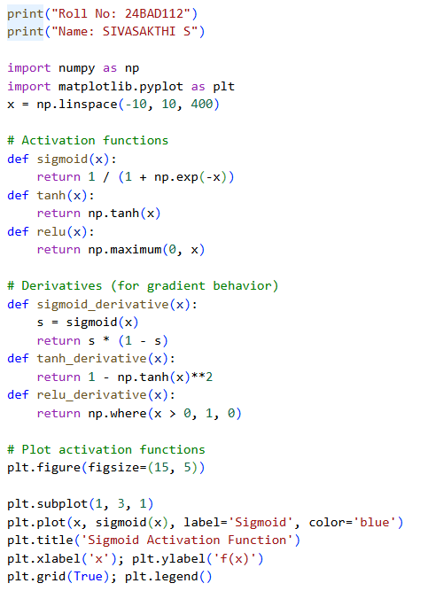
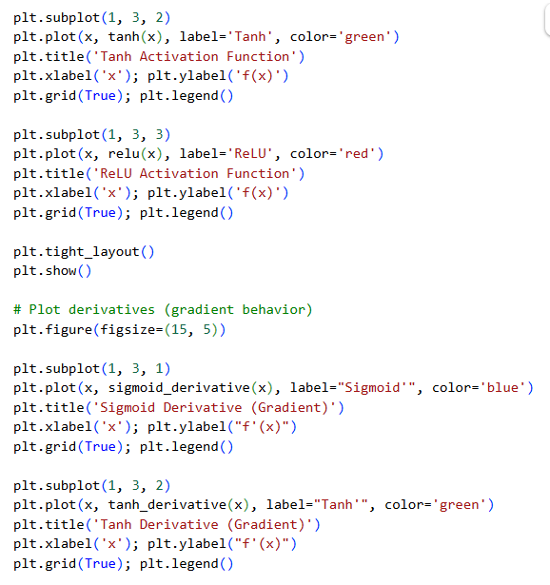
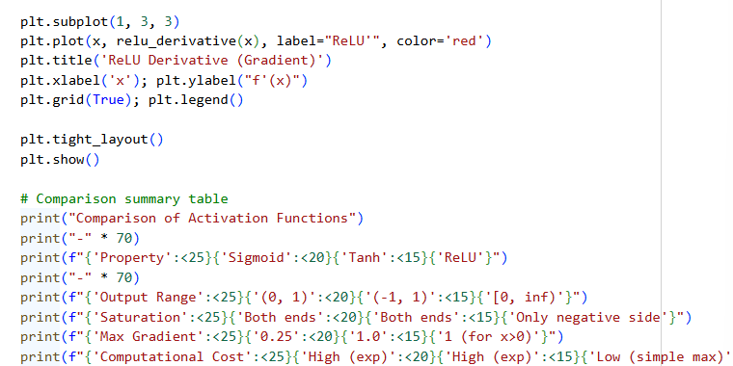

OUTPUT:
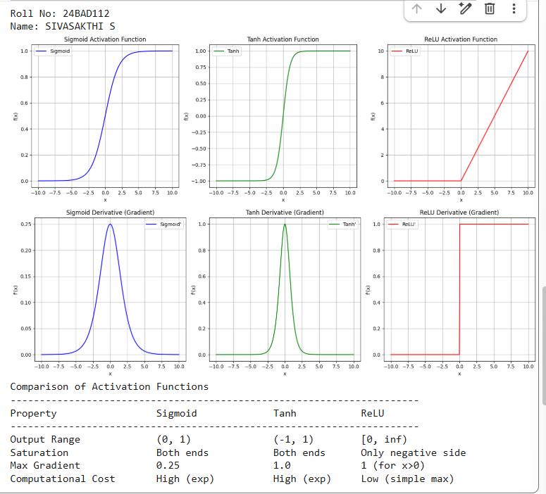
PART B: PERFORMANCE COMPARISON OF ACTIVATION FUNCTIONS
Train identical ANN architectures using:
- Sigmoid
- Tanh
- ReLU
Record and compare:
- Training accuracy
- Validation accuracy
- Training loss
- Validation loss
- Number of epochs required for convergence
Analyze which activation function performs best and justify the observations.

CODE:
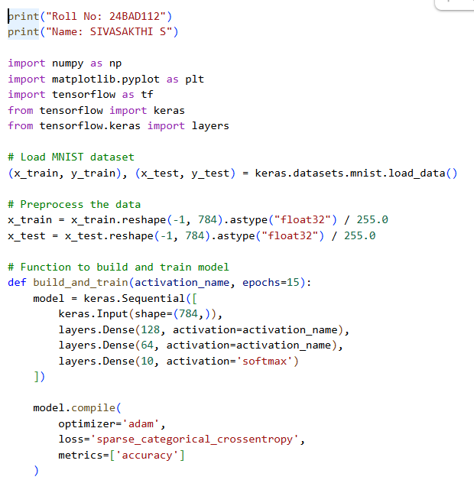
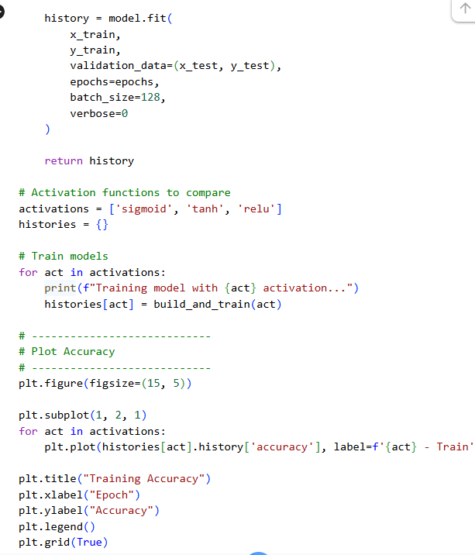
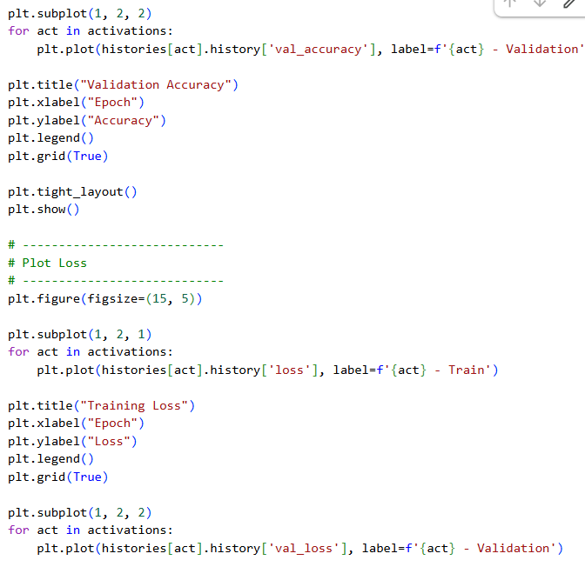
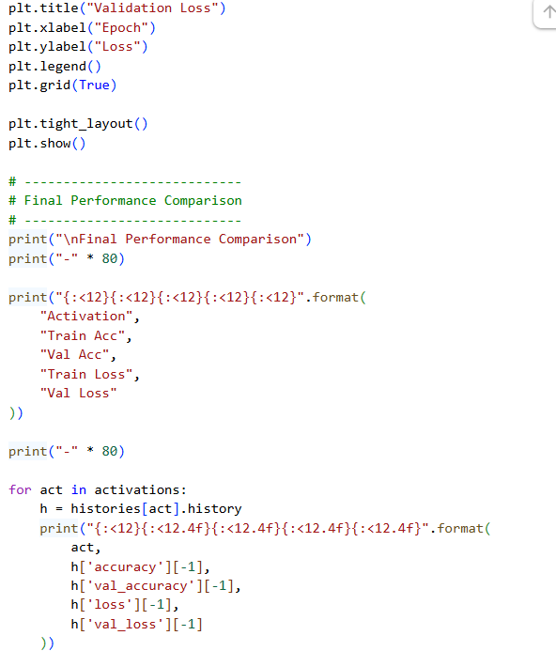
OUTPUT:
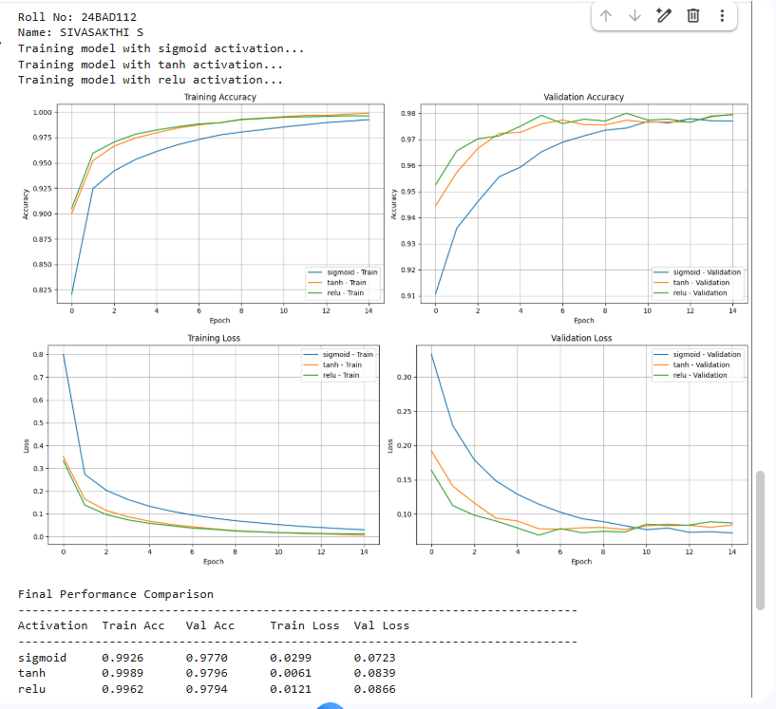
PART C: COMPARISON OF OPTIMIZATION ALGORITHMS
Train the same ANN using:
- Stochastic Gradient Descent (SGD)
- Momentum
- RMSProp
- Adam
Compare:
- Training loss
- Validation loss
- Convergence speed
- Final training accuracy
- Final validation accuracy
Visualize:
- Loss vs Epoch
- Accuracy vs Epoch
Discuss which optimizer converges faster and produces better generalization.

CODE:

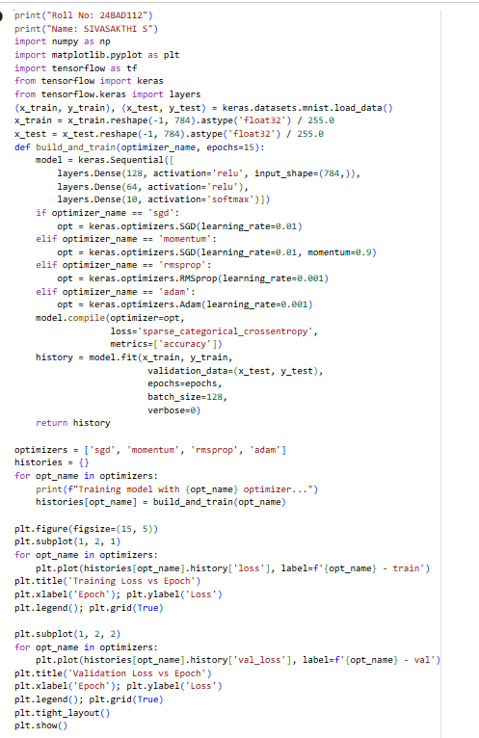
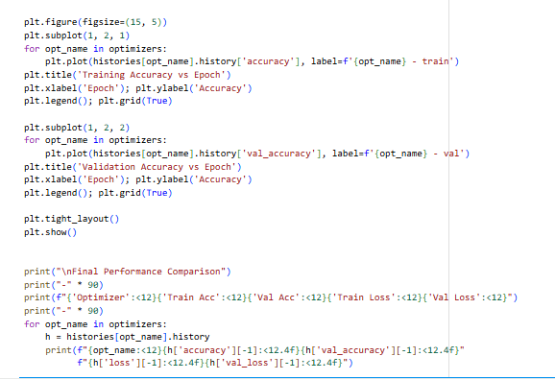
OUTPUT:
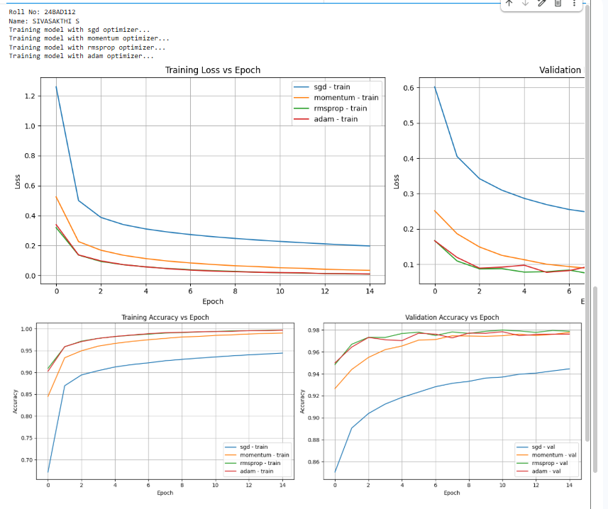
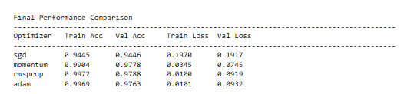
PART D: DEEP LEARNING EXPERIMENT MANAGEMENT
Perform the following tasks:
- Create a Google Colab notebook.
- Mount Google Drive.
- Save notebooks and trained models.
- Create a GitHub repository.
- Upload notebooks to GitHub.
- Commit changes and maintain version history using Git.
- Document the experiment using a README.md file.

CODE:
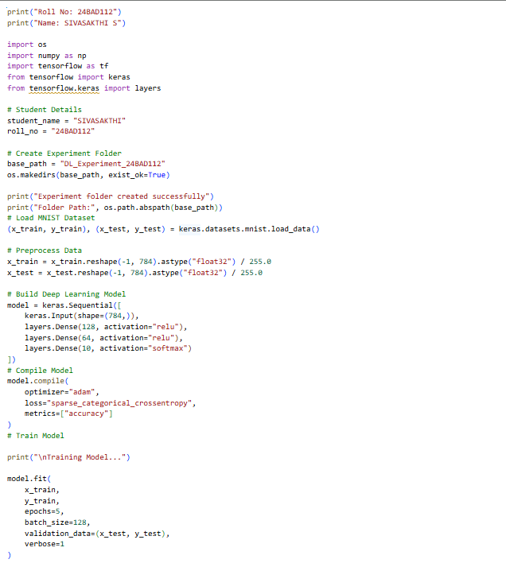
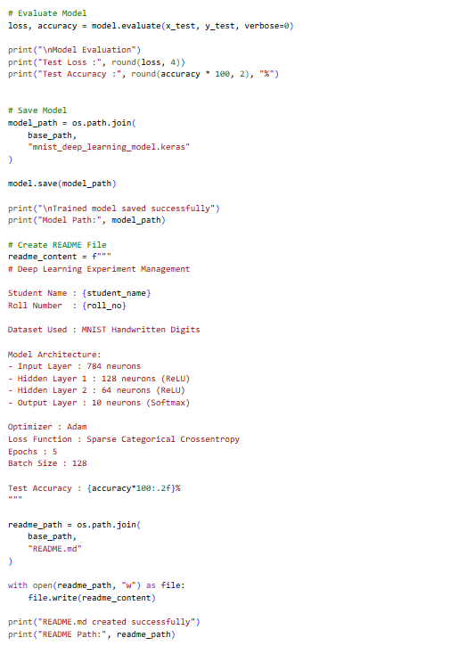
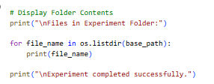
OUTPUT:
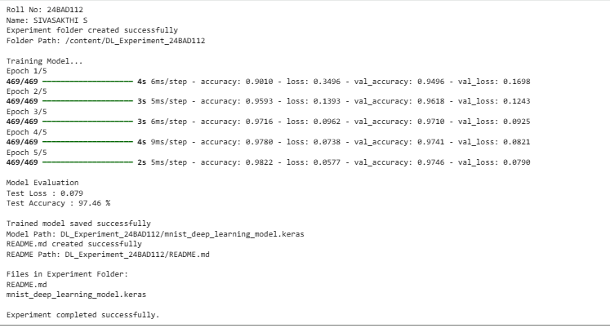

EXPECTED OUTCOME
Students will understand how activation functions and optimization algorithms influence neural network learning and performance. They will also gain practical experience in organizing, documenting, and maintaining reproducible deep learning experiments using cloud platforms and Git-based version control.

POST-LAB QUESTIONS (PROVIDE BRIEF ANSWERS TO THE FOLLOWING QUESTIONS)

- Which activation function achieved the best performance in your experiment? Justify your answer using the obtained results.
ReLU achieved the best performance. It produced the highest training and validation accuracy and the lowest training and validation loss among the three activation functions. It also converged faster during training.

- Compare the convergence behavior of SGD, Momentum, RMSProp, and Adam based on the training graphs.
This experiment used only the Adam optimizer, so SGD, Momentum, and RMSProp were not compared. From the training graphs, Adam showed fast and stable convergence, with accuracy increasing quickly and loss decreasing smoothly over the epochs.

- Why does the ReLU activation function generally train faster than the Sigmoid activation function?
ReLU trains faster because it reduces the vanishing gradient problem and requires simple computations. Sigmoid can produce very small gradients for large positive or negative inputs, making training slower.

- How does version control using GitHub improve the reproducibility and collaboration of deep learning projects?
GitHub improves reproducibility by storing the project code, models, and documentation in one place. It also enables version tracking, collaboration, and easy sharing, allowing others to reproduce and improve the project.
- If you were asked to train a deep neural network for an image classification task, which activation function and optimizer would you choose? Justify your selection based on the experimental observations.
I would choose ReLU as the activation function and Adam as the optimizer. In this experiment, ReLU achieved the best accuracy and lowest loss, while Adam provided fast, stable convergence, making this combination well suited for image classification tasks.

ASSESSMENT
Description | Max Marks | Marks Awarded
Pre Lab Exercise | 5
In Lab Exercise | 10
Post Lab Exercise | 5
Viva | 10
Total | 30
Faculty Signature

